Re-Taking of Pelham One Two Three
Quote Sheet

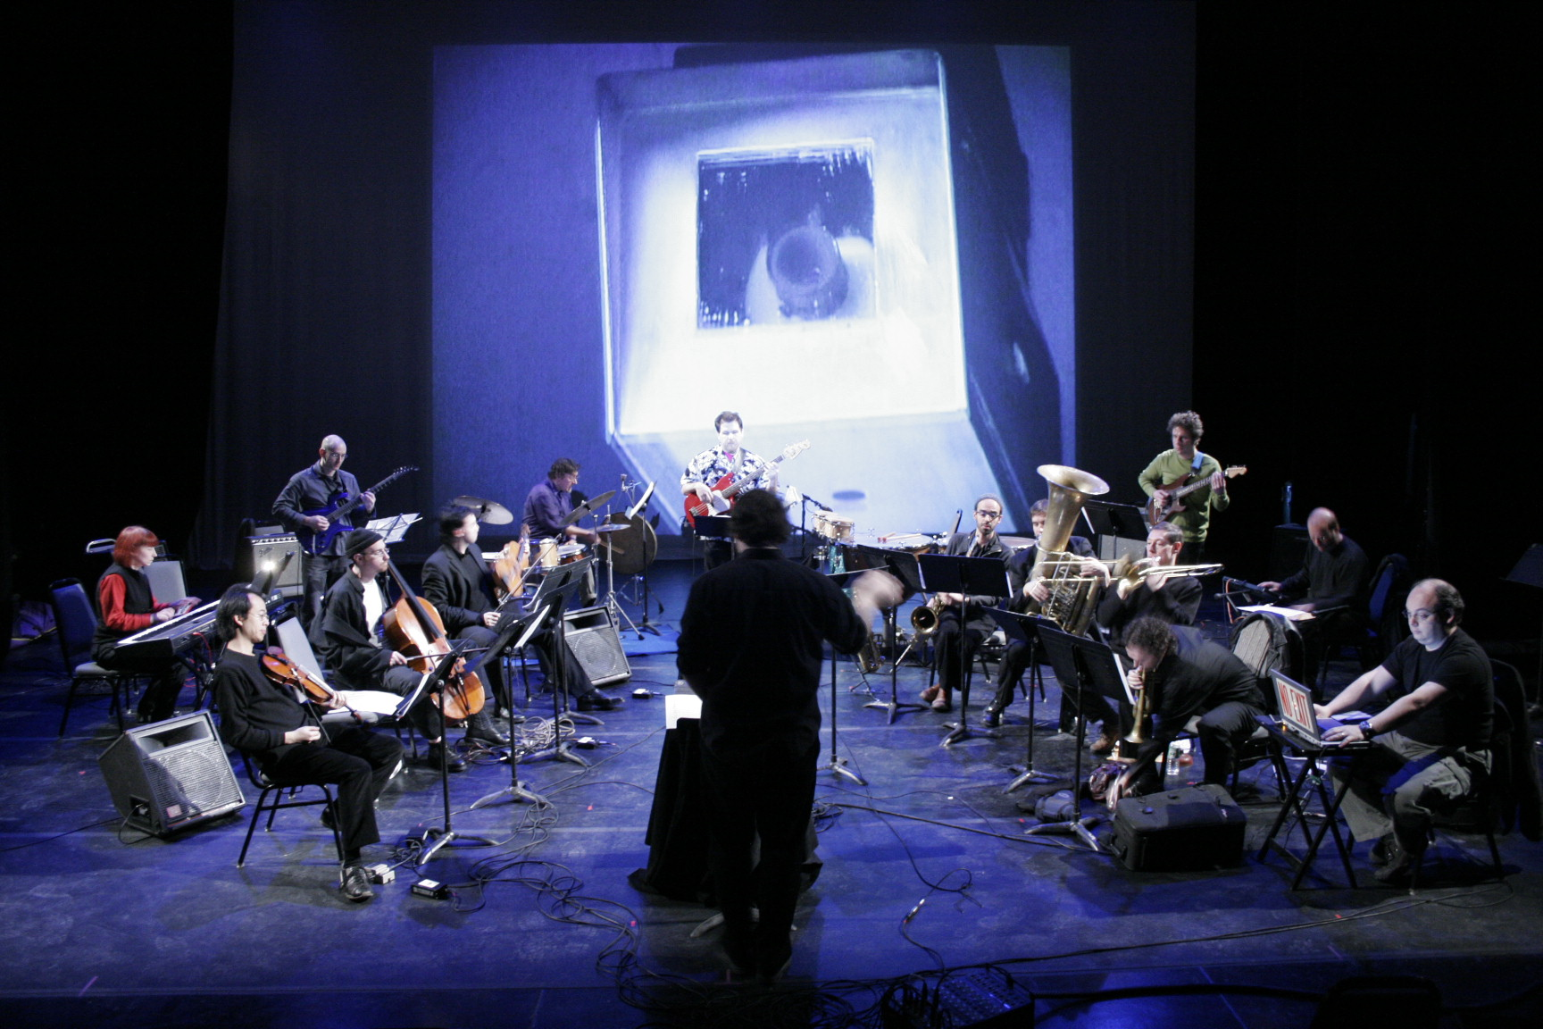

"Steve and Jane used a unique process to create an absolutely original piece, one that evokes the 1970s while delivering a contemporary message. I really appreciated the way the music and film played off each other, the layering of film, music and sound samples from the original had a timeless quality” Joe Carroll, composer & founder of the Manhattan Producers Alliance

“Steve Horowitz’ creation is an imaginative updating of composer David Shire’s score for the 1974 film “The Taking of Pelham One Two Three”. At a winter performance at NYC arts stronghold The Kitchen, Horowitz and a 14-piece orchestra -- with everything from violins to electric guitar and laptop sampler in the mix -- performed the swelling, tense car-chase jazz-funk piece live against the backdrop of a new short film by filmmaker Jane Brill.” – David Weiss, Mix magazine

"With the drive of a speeding train and the virtuosity of the big bands of yesterday, "The Re-Taking of Pelham One Two Three" will have you up and shouting" -Steven. D. Lavine, President/ California Institute of the Arts

"What most struck me about Steve’s music is that if I were hired to score this picture today instead of 1974, I would hope that my score would come out sounding the way that Steve’s does." – David Shire, composer

”For me, the Re-Taking of Pelham One Two Three was like a fast ride on a crazy train. Steve very cleverly took the energetic materials from the original masterpiece soundtrack and re-fashioned them for the 21st Century. His piece crosses over onto the multimedia concert stage, and just as the original pulsated with evocations of 70's New York, Steve's work makes us feel the human condition of today's New Yorkers. And it's a blast to play!” -Kathy Supove, Pianist

